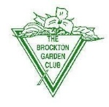
PLANT SALE
BROCKTON GARDEN CLUB
Saturday May 17, 2025
8:30 a.m. – 11:00 a.m.
*****************************************************************************
New plants, Old Favorites
Perennials -Shrubs – Herbs – Daylily’s
*************************************************************************************
Most plants grown locally in our own gardens
Brockton Park Department, 45 Meadow Lane
(off South Main Street, opposite HarborOne Credit Union)
(Former site of the Campello Swimming Pool)
***Proceeds fund our city-wide Civic Projects ****
*** Bring your used plant pots, we recycle***

